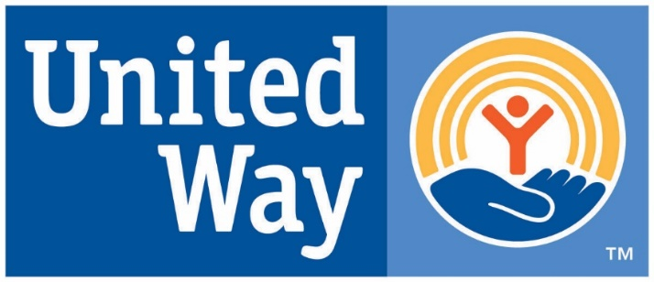
TRI-COUNTY UNITED WAY

For Immediate Release

Media Contact:

Kathy Tolstrup
518-793-3136
ktolstrup@tricountyunitedway.org

Tri-County United Way Distributes Generous Gift from Delta Airlines

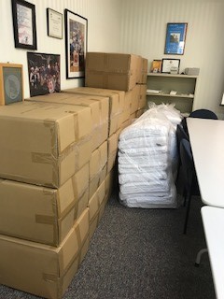
(Queensbury, New York) December 22, 2020 – Tri-County United Way distributed a Delta Airlines donation of more than 1,000 travel blankets to 15 local food pantries and shelters. As the temperatures drop and the corona virus pandemic continues to create hardships for local families, the gift of warmth from Delta’s blankets has been a welcome surprise for many. The blankets were distributed in holiday baskets from local food pantries and the first class travel blankets are now covering the beds at local shelters.

“We are so grateful to The Salice Family Foundation for sharing Delta’s gift with the Tri-County United Way. Their generosity and support during this challenging year allows us to continue helping struggling local families,” said Peter Aust, Interim Executive Director.

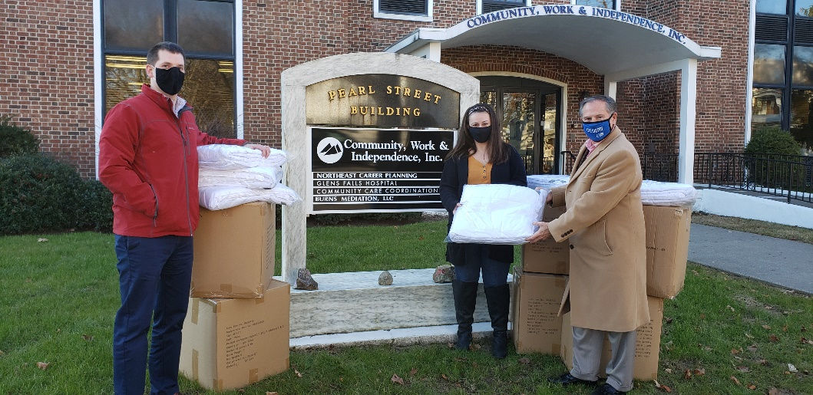
Accepting blankets for CWI - Dan Juidiciani, Division Director of Residential Services and Nellie Long, Director of Residential Services from Tri-County United Way’s Interim Executive Director, Peter Aust.

About Tri-County United Way
Tri-County United Way fights for the Health, Education and Financial Stability of every person in our community. The agency collaborates, convenes, and partners to support programs and initiatives that break the cycle of poverty, promote a healthy community where children are successful from kindergarten through graduation to a career, and where families have the tools, skills, and support they need to become financially independent. We win by living United. For more information about Tri-County United Way, visit tricountyunitedway.org. Headquarters are at 696 Upper Glen Street, Queensbury, and NY 12804. 518.793.3136
For more information or to schedule an interview with Tri-County United Way's staff, please contact Kathy Tolstrup at ktolstrup@tricountyunitedway.org, 518.793.3136.

